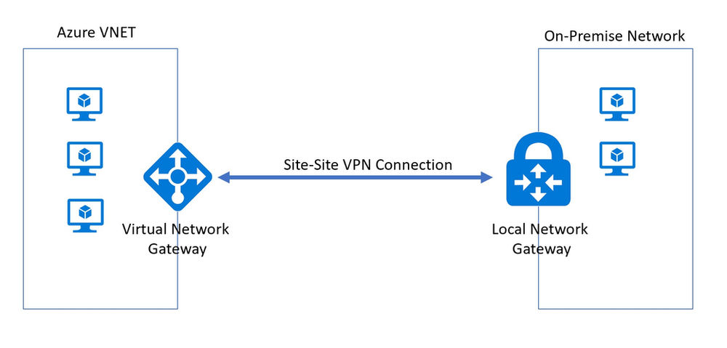

**Azure Virtual Network Gateway and Local Network Gateway**

**1. Introduction**

Azure provides networking components that enable hybrid connectivity between an on-premises network and an Azure Virtual Network (VNet). Two critical components for this are **Azure Virtual Network Gateway (VNG)** and **Local Network Gateway (LNG)**.

**2. Azure Virtual Network Gateway**

**2.1 Overview**

An Azure Virtual Network Gateway enables secure communication between an Azure VNet and external networks, such as an on-premises network, another Azure VNet, or the Internet.

**2.2 Use Cases**

* **Site-to-Site VPN**: Connects an on-premises network to Azure securely over IPsec/IKE.
* **Point-to-Site VPN**: Allows remote users to connect securely to Azure resources.
* **ExpressRoute**: Provides private, dedicated connectivity between Azure and on-premises.
* **VNet-to-VNet Connectivity**: Enables communication between two Azure VNets via a VPN.

**2.3 Gateway Types**

* **VPN Gateway**: Uses IPsec/IKE for secure VPN connections.
* **ExpressRoute Gateway**: Supports private, dedicated connectivity through ExpressRoute.

**2.4 Gateway SKUs**

| **SKU** | **VPN Tunnels** | **Aggregate Throughput** | **Connection Type** |
| --- | --- | --- | --- |
| Basic | 10 | 100 Mbps | Route-Based, Policy-Based |
| VpnGw1 | 30 | 650 Mbps | Route-Based |
| VpnGw2 | 30 | 1 Gbps | Route-Based |
| VpnGw3 | 30 | 1.25 Gbps | Route-Based |

**2.5 Deployment Steps**

1. **Create a Virtual Network**: Define address spaces and subnets.
2. **Deploy a Virtual Network Gateway**: Select VPN or ExpressRoute and assign a public IP.
3. **Configure Connections**: Define VPN tunnels or ExpressRoute circuits.

**3. Azure Local Network Gateway**

**3.1 Overview**

A Local Network Gateway (LNG) represents an on-premises network within Azure. It stores configuration details such as the public IP of the VPN device and the address space of the internal network.

**3.2 Use Cases**

* Required for setting up **Site-to-Site VPN** connections.
* Enables **BGP (Border Gateway Protocol)** for dynamic routing.
* Supports **multiple address prefixes** to define multiple on-premises subnets.

**3.3 Configuration Steps**

1. **Create a Local Network Gateway** in Azure.
2. **Provide On-Premises VPN Device Public IP**.
3. **Define Address Spaces** for on-premises networks.
4. **Link to Virtual Network Gateway** for Site-to-Site VPN setup.